ASSIGNMENT 6.5
NAME: MD.Arshad
HT NO: 2303A51334
BATCH: 20

Task Description #1 (AI-Based Code Completion for Conditional Eligibility Check) Task: Use an AI tool to generate eligibility logic.
Prompt:
“Generate Python code to check voting eligibility based on age and citizenship.” Expected Output:
- AI-generated conditional logic.
- Correct eligibility decisions.
- Explanation of conditions. CODE:
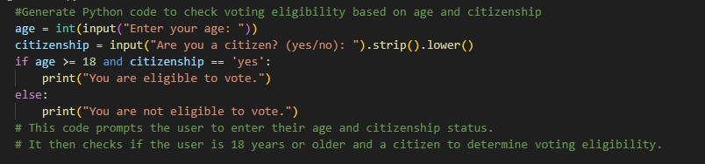

Output:

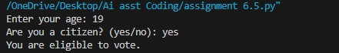

Task Description #2(AI-Based Code Completion for Loop-Based String Processing) Task: Use an AI tool to process strings using loops.
Prompt:
“Generate Python code to count vowels and consonants in a string using a loop.” Expected Output:
- AI-generated string processing logic.
- Correct counts.
- Output verification.

CODE:
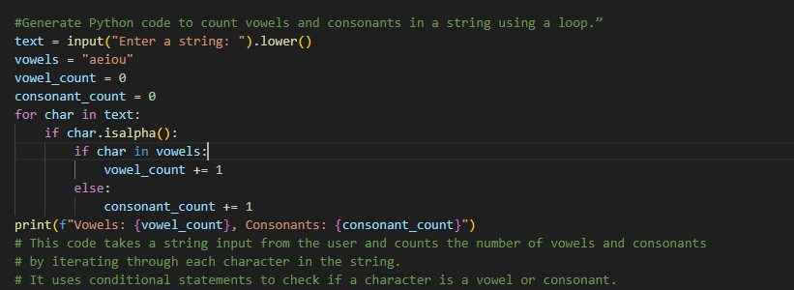

OUTPUT:

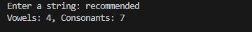

Task Description #3 (AI-Assisted Code Completion Reflection Task)
Task: Use an AI tool to generate a complete program using classes, loops, and conditionals.
Prompt:
“Generate a Python program for a library management system using classes, loops, and conditional statements.”
Expected Output:
- Complete AI-generated program.
- Review of AI suggestions quality.
- Short reflection on AI-assisted coding experience.

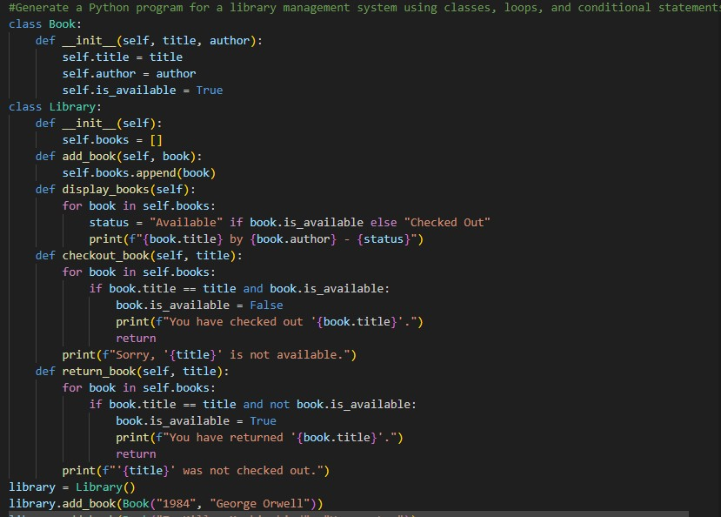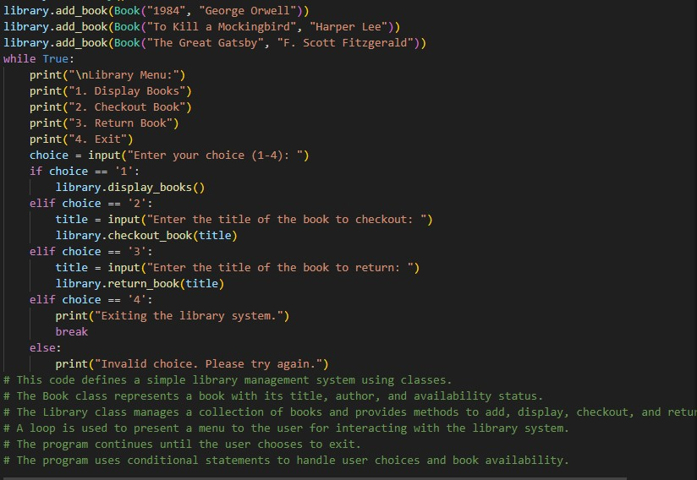

OUTPUT:
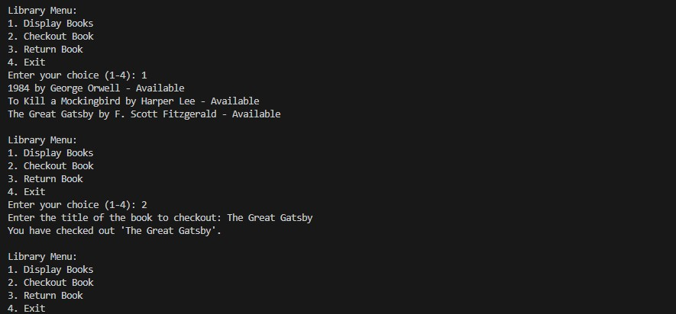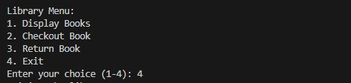

Task Description #4 (AI-Assisted Code Completion for Class- Based Attendance System) Task: Use an AI tool to generate an attendance management class.
Prompt: “Generate a Python class to mark and display student attendance using loops.” Expected Output:
- AI-generated attendance logic.
- Correct display of attendance.
- Test cases.

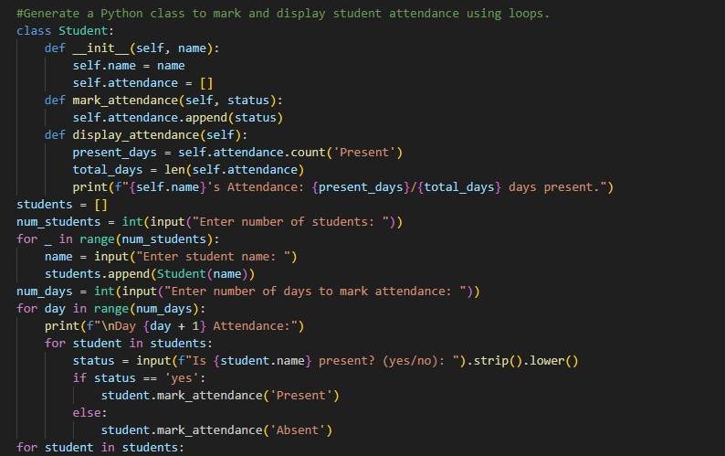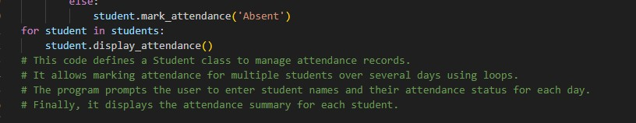

OUTPUT:
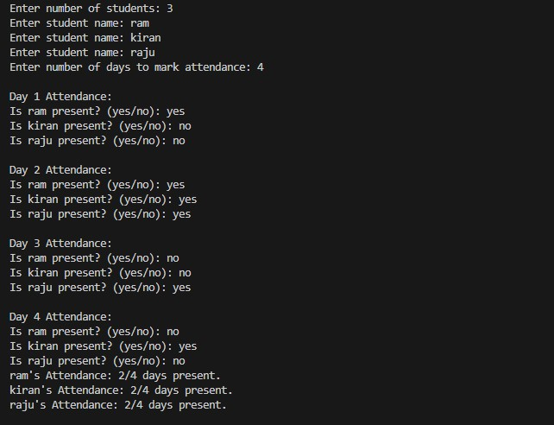

Task Description #5 (AI-Based Code Completion for Conditional Menu Navigation) Task: Use an AI tool to complete a navigation menu.
Prompt: “Generate a Python program using loops and conditionals to simulate an ATM menu.” Expected Output:
- AI-generated menu logic.
- Correct option handling.
- Output verification.

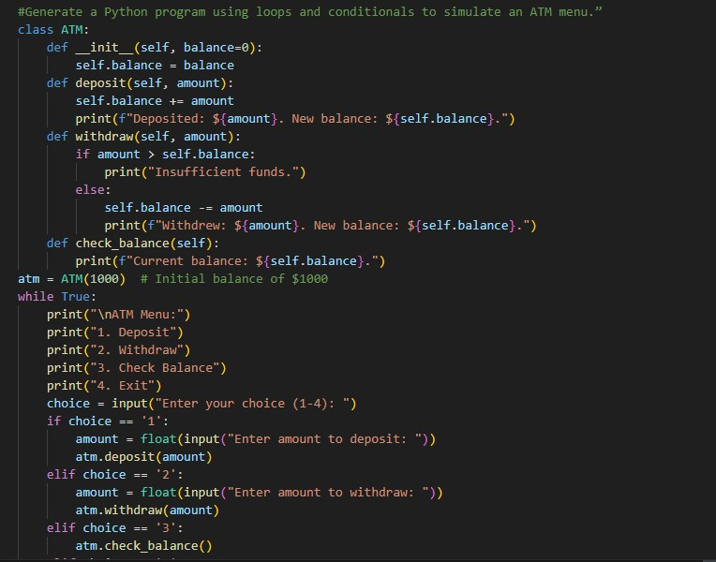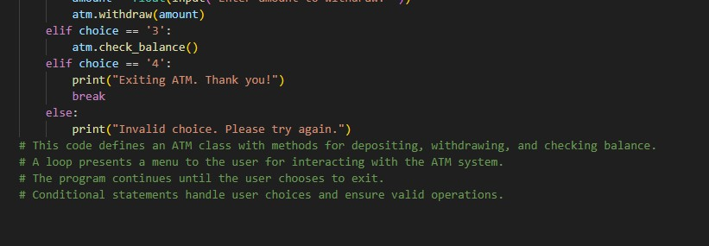

OUTPUT:
